Network Enterprise ITNW 2350

Lab 3.1.1d

GYIMP

Jacob Calvert, Timothy Zellers, Regan Stubbs, James Baker, Faustino Gonzolez

Criteria #1: Client Joined Domain

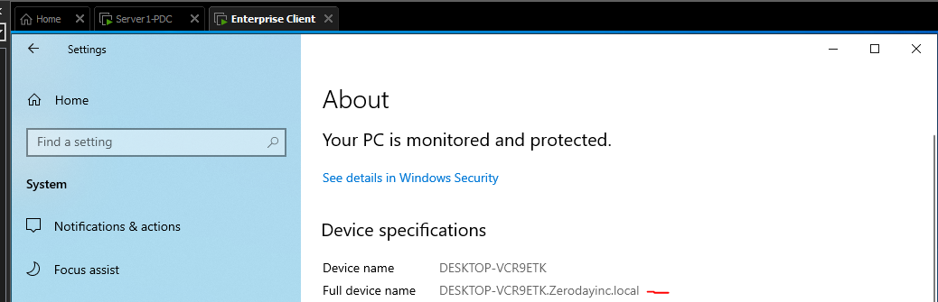

Criteria #2: Client obtained IP address from DHCP

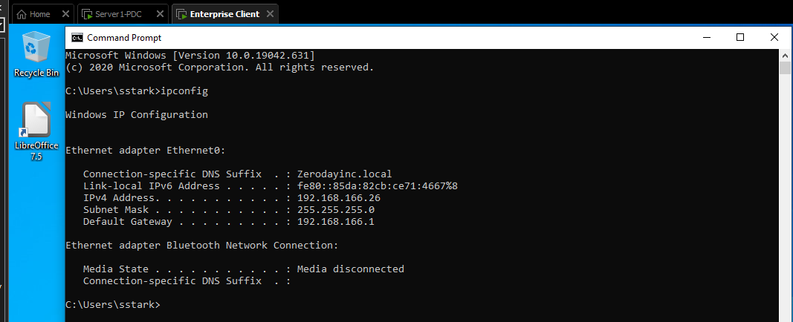

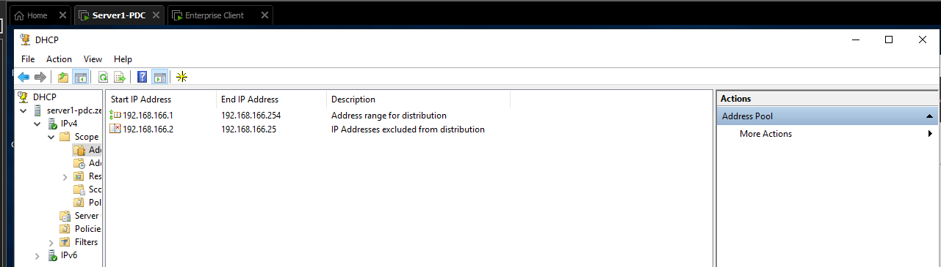

Criteria #3: Libre/Open Office Suite Installed

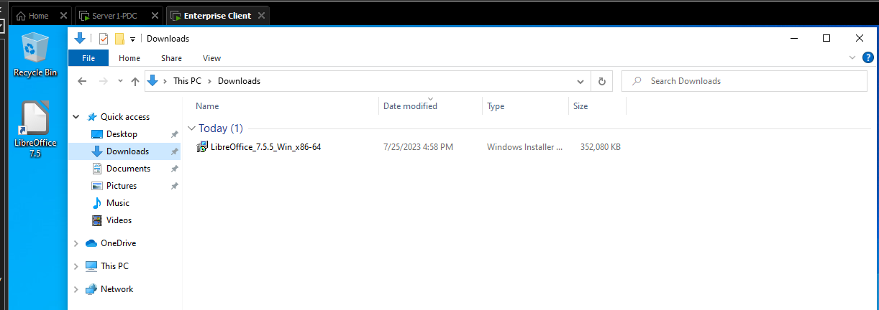

Criteria #4a: Network Resources Access: Drive Mapping to the user’s home folder & dept. share

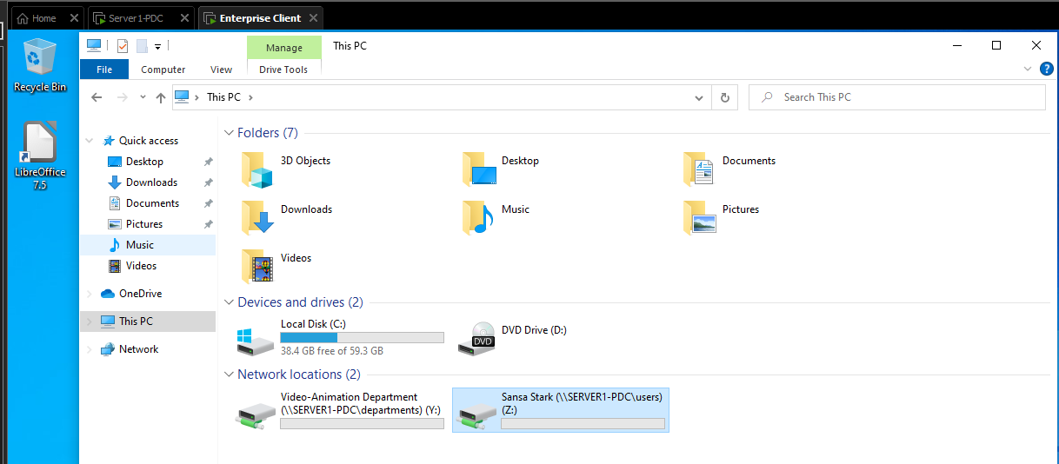

Criteria #4b: Network Resources Access: network printer installed

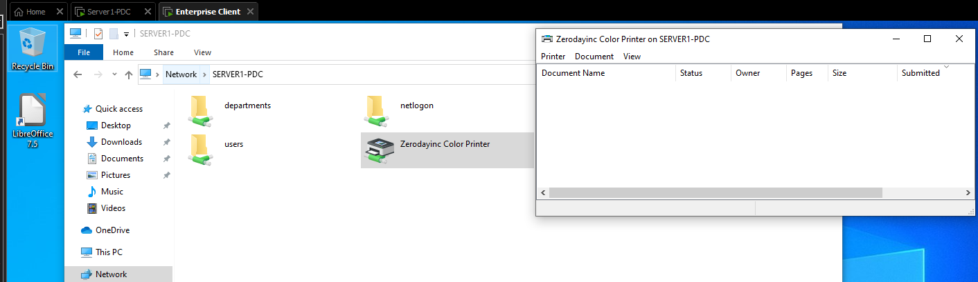

Criteria #4c: Network Resources Access: To internal Web server HTTP / HTTPS

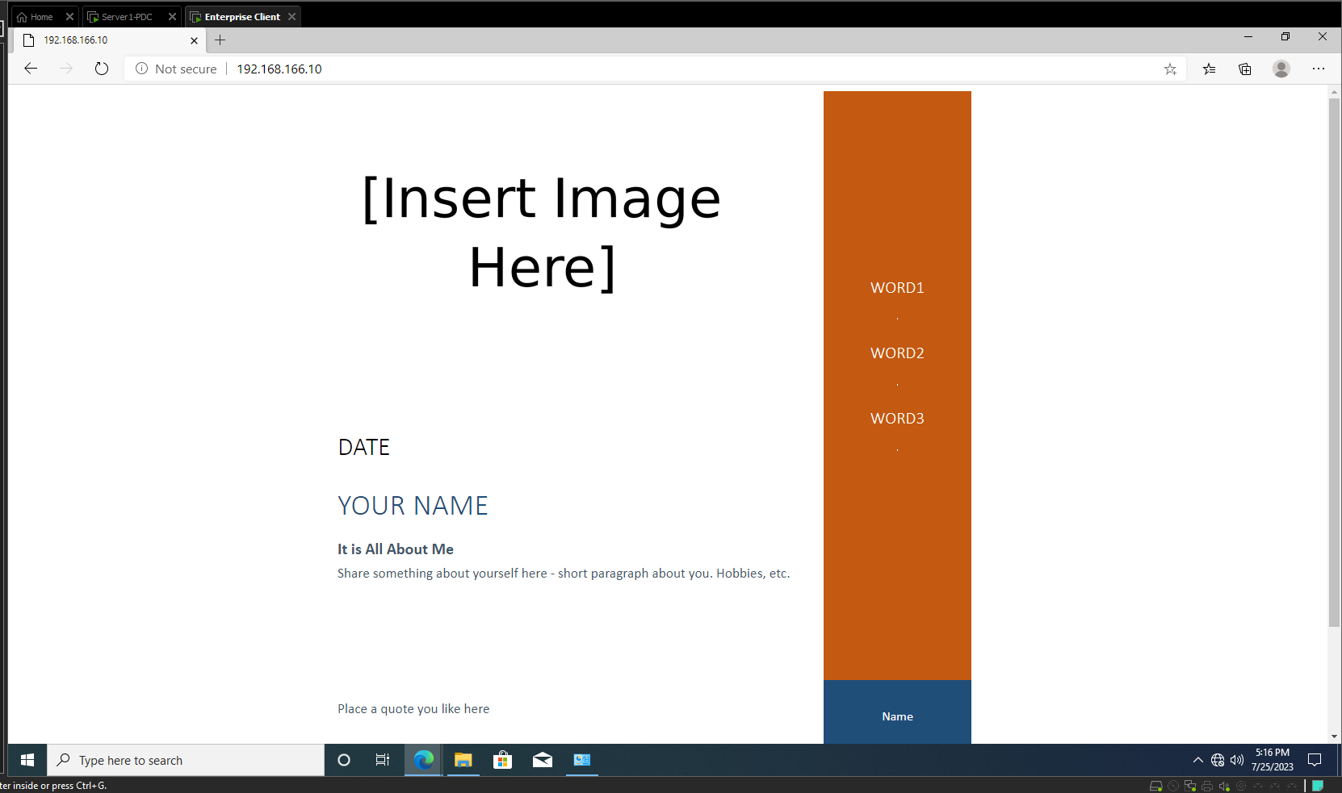

Criteria #4d: Network Resources DMZ Access: FTP / Secure FTP Server to upload & download files

